DATE: **March 2, 2021**

TO: **Dr. Deirdre Hunter**

FROM: **Sindhuja Darisipudi, Nora Han, Joseph Urso, Michael Tang, Jason Ye[1]**

**Team Moonrats (**[**5moonrats@gmail.com**](mailto:5moonrats@gmail.com)**)**

SUBJECT: **Water Assessment Incubator Brainstorming Process and Outcomes**

**Brainstorming Process Overview**

Our design challenge is to build a portable incubator that enables E. coli to be grown on Petrifilms. We recently conducted a brainstorming session to ideate solutions for this problem.

We primarily used the writing slip method for brainstorming, where each of us wrote and/or sketched one idea per sticky note. We drew our inspiration strongly from the existing incubator and similar heating devices. After around 20 minutes, we reconvened, discussed what ideas we had come up with, and then combined ideas to create new ones.

However, within the first few minutes of the brainstorming, we realized ideating an entire incubator was far too broad; as a result, we first decomposed our design challenge into design blocks. We then decided to draw one idea from each design block per sticky note. When sharing, we took turns to share, ensuring that our remote teammates were able to share their ideas as well. The design blocks are visualized in Figure 1 below.



***Figure 1: Incubator Decomposition Flow Chart***

As is evident from Figure 1, we first began by decomposing our problem into 4 overarching design blocks: temperature adjustment, data collection, power source, and physical construction. After discussion, however, we decided that a few of these design blocks needed even greater granularity. For instance, we realized that heating and cooling, despite both falling under the umbrella of temperature control, involve very different processes, and hence deserved separate consideration when brainstorming. A similar thought process motivated the other further design block decompositions. We utilized the block decompositions to organize our discussion when we reconvened after discussion.

**Brainstorming Results**

We used the design blocks described in Figure 1 to guide our brainstorming. The results of this are visualized in Figures 2 through 8. The brainstorming is split into the sections at the lowest level in Figure 1.

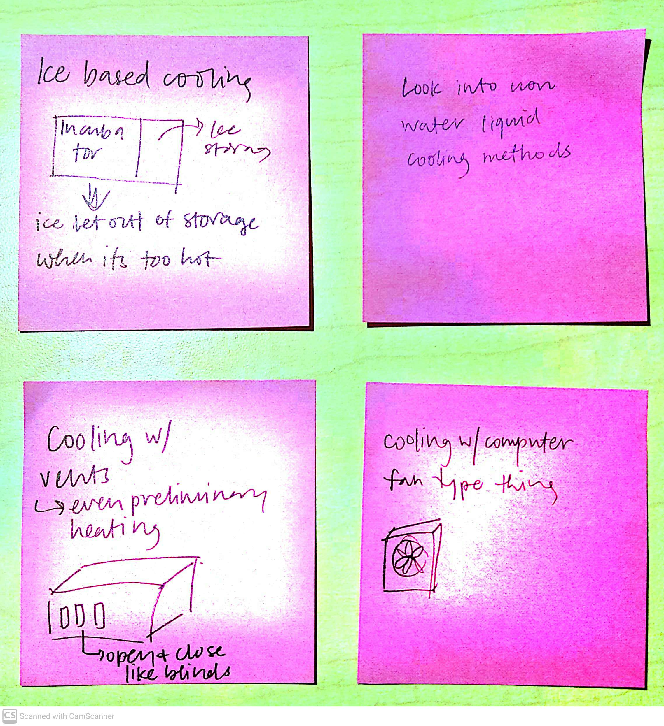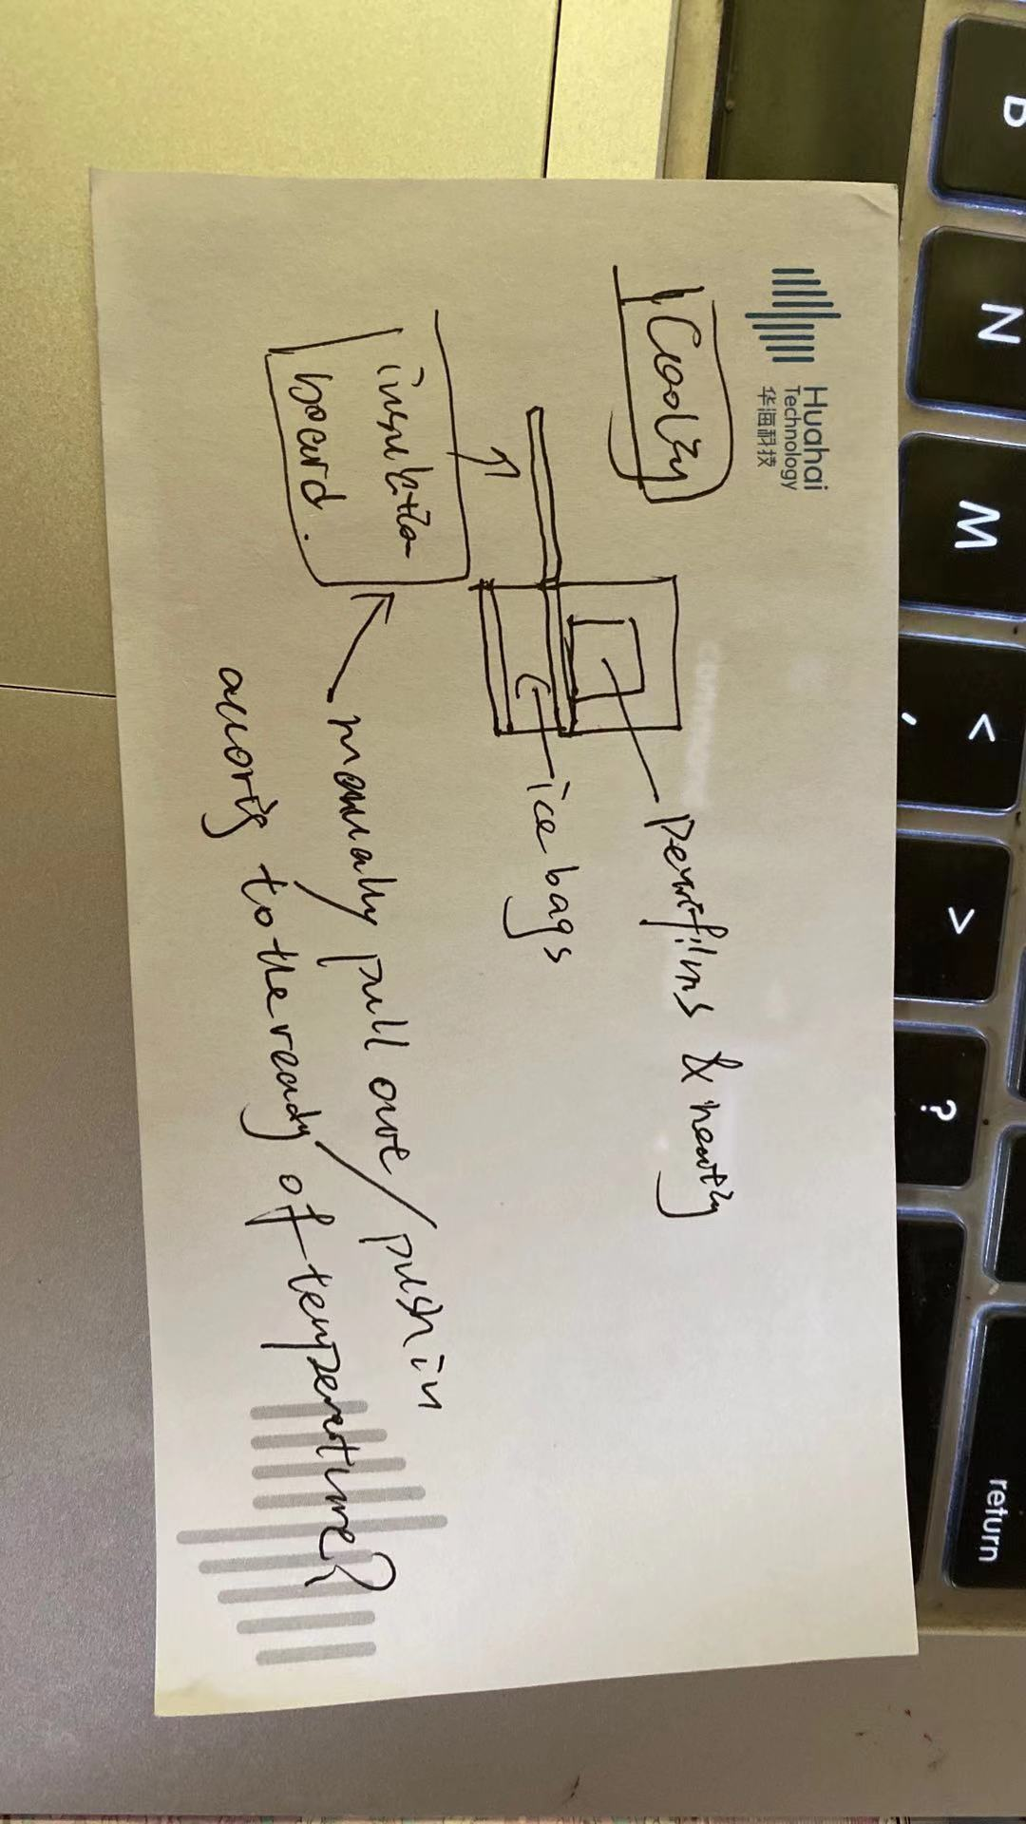

***Figure 2: Cooling Block Brainstorming***

An assortment of sticky notes depicting ideas that our team had for cooling

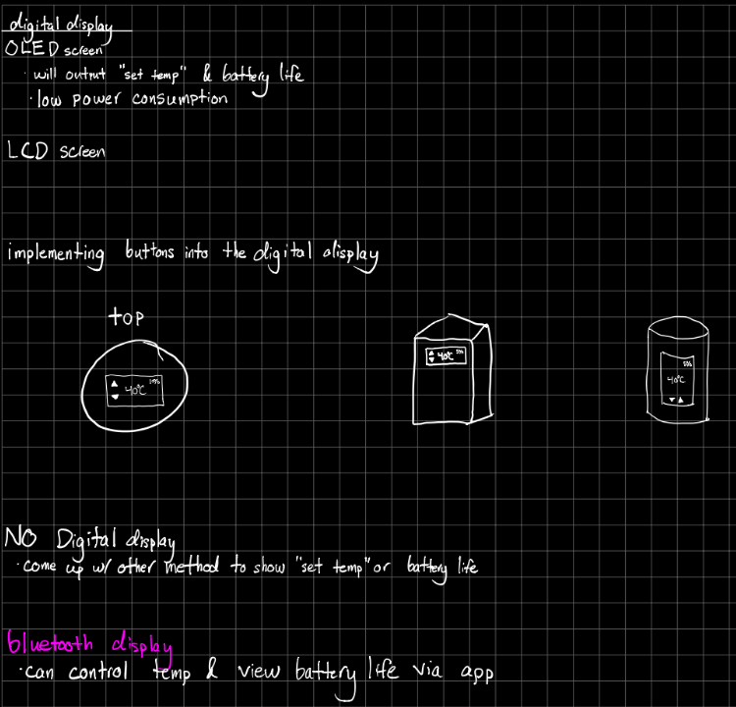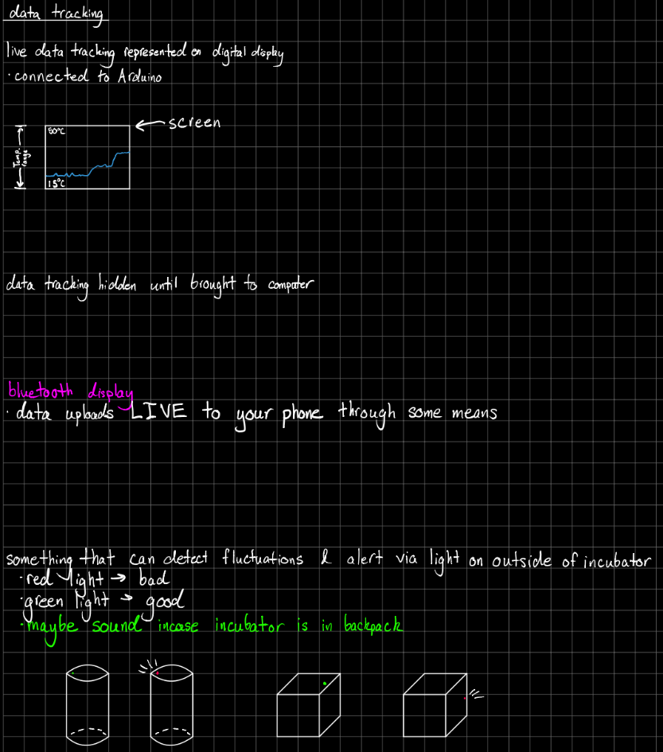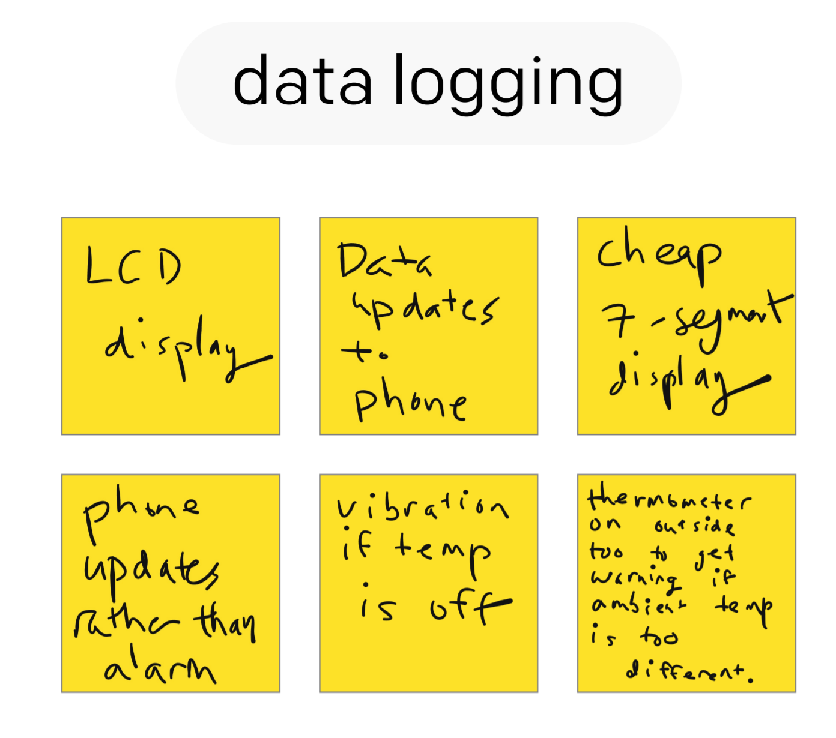

***Figure 3: Data Tracking Brainstorming***

An assortment of sticky notes and notes depicting ideas that our team had for data tracking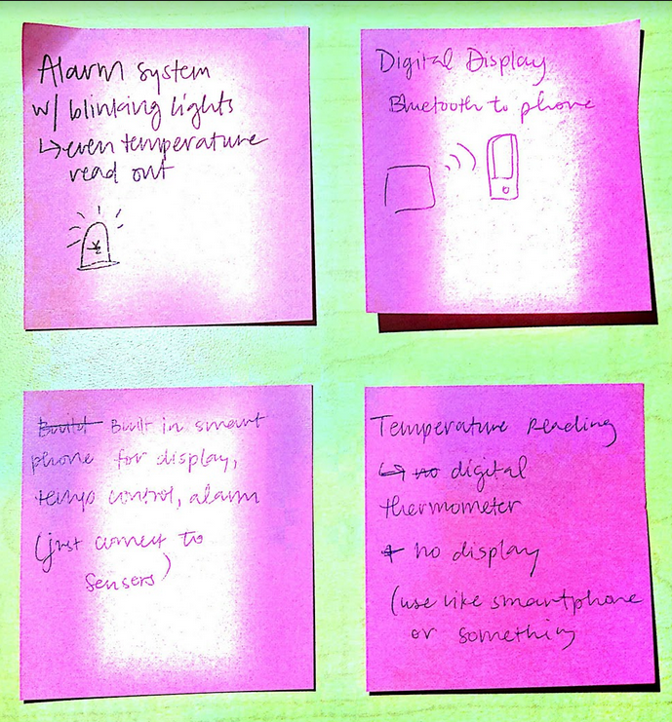

***Figure 4: Digital Display Brainstorming***

An assortment of sticky notes and notes depicting ideas that our team had for the digital display

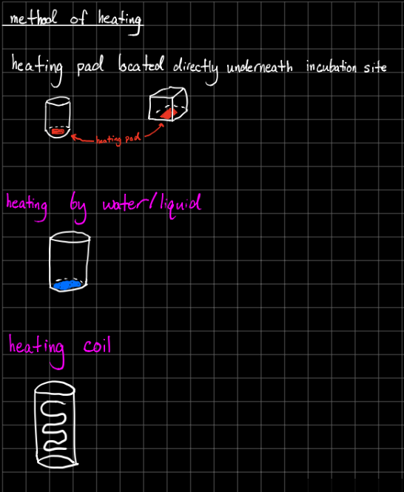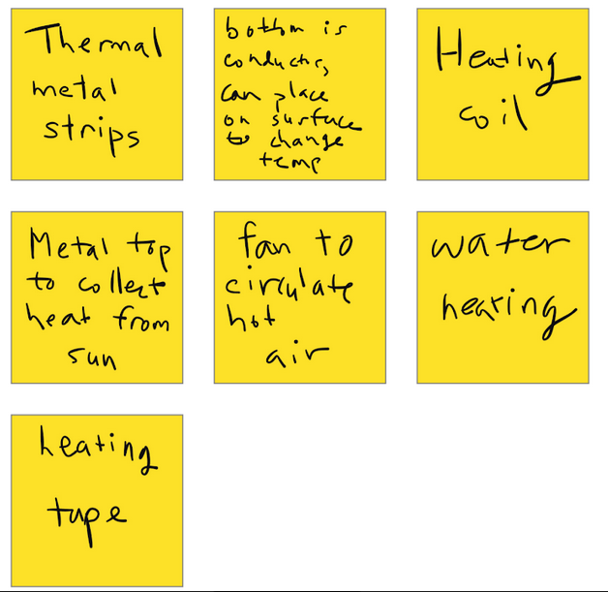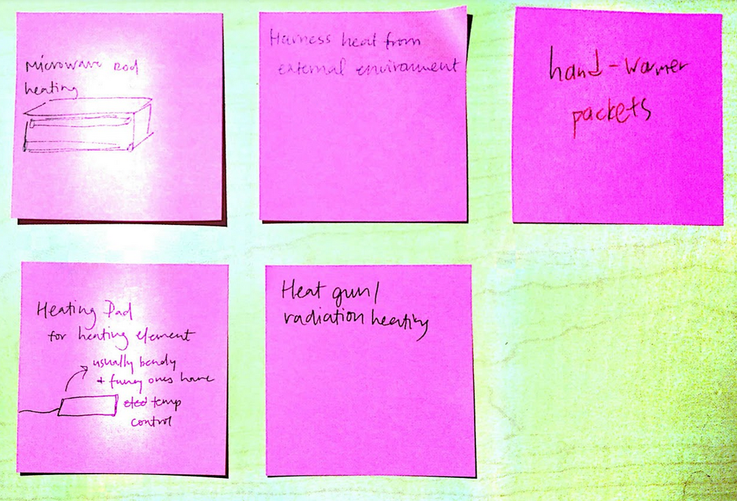

***Figure 5: Heating Brainstorming***

An assortment of sticky notes and notes depicting ideas that our team had for heating

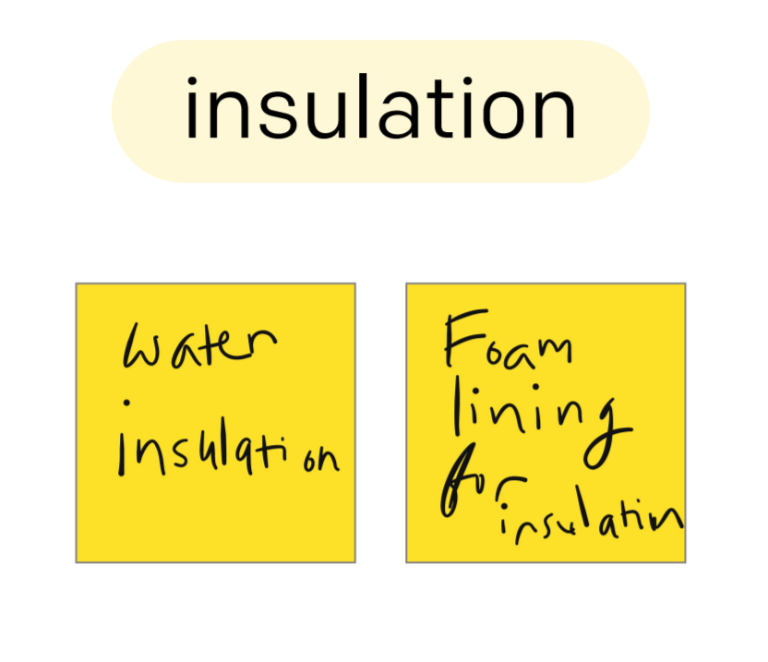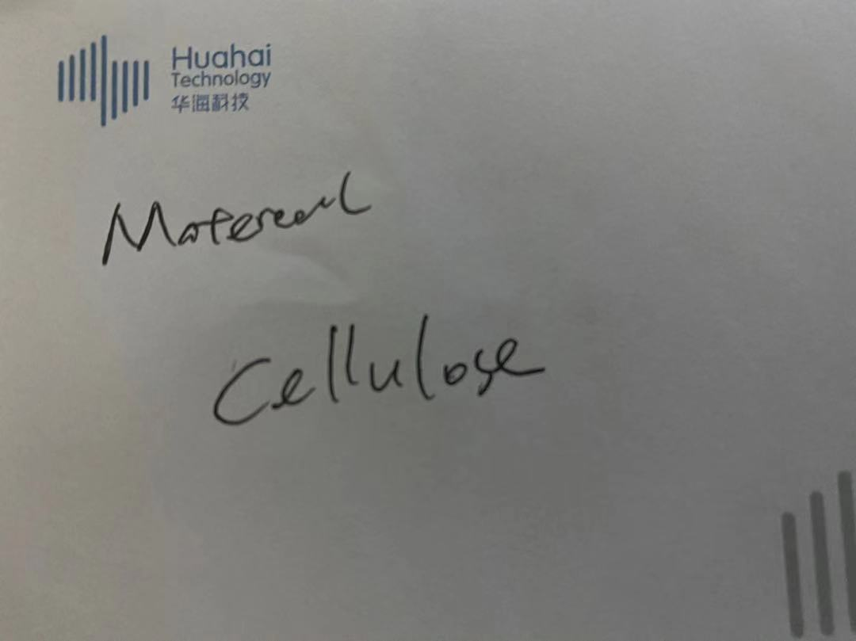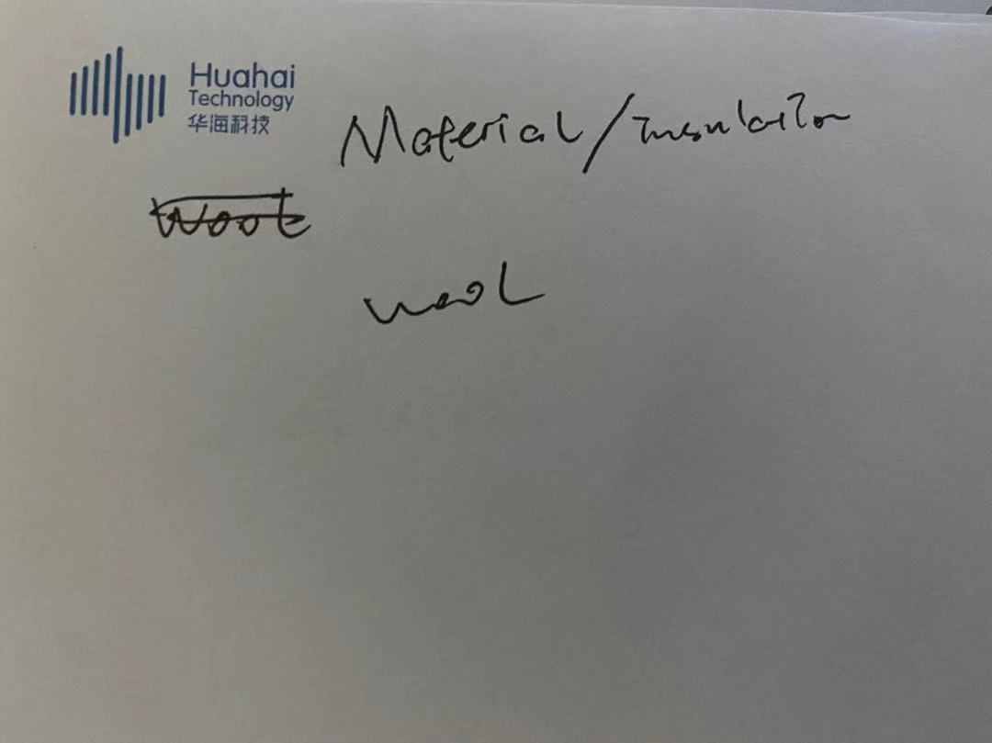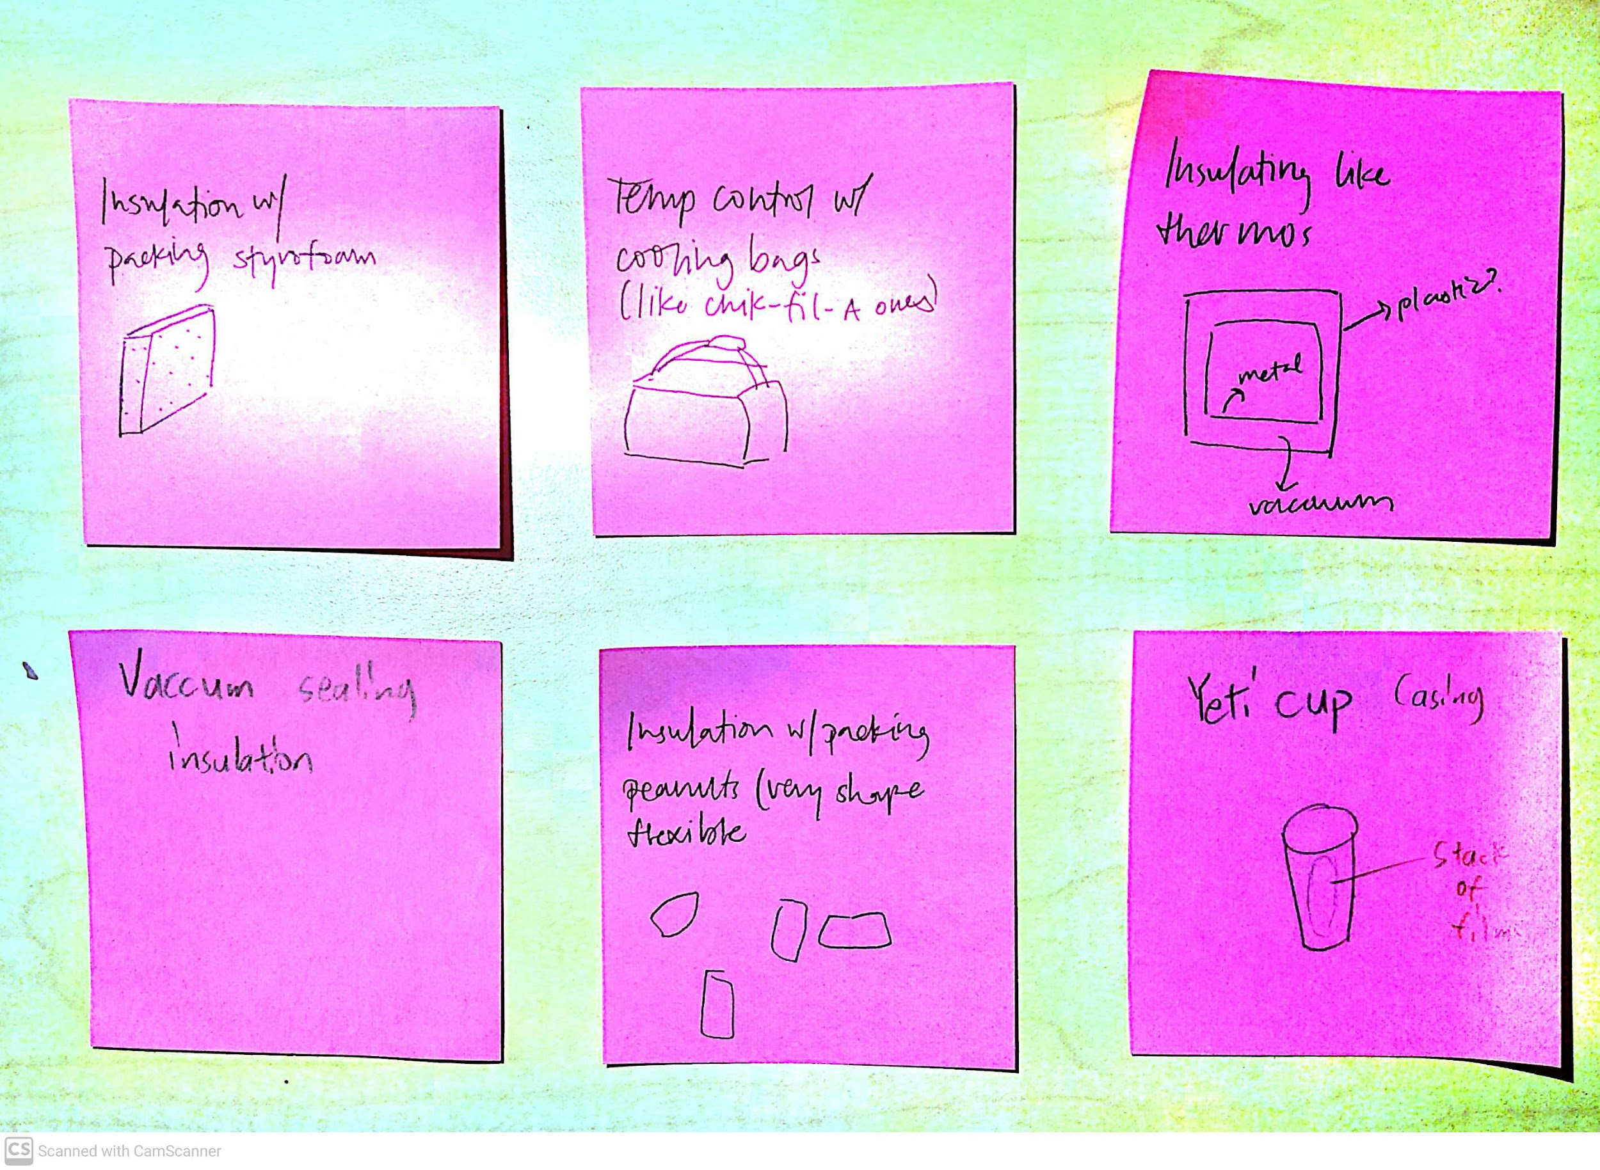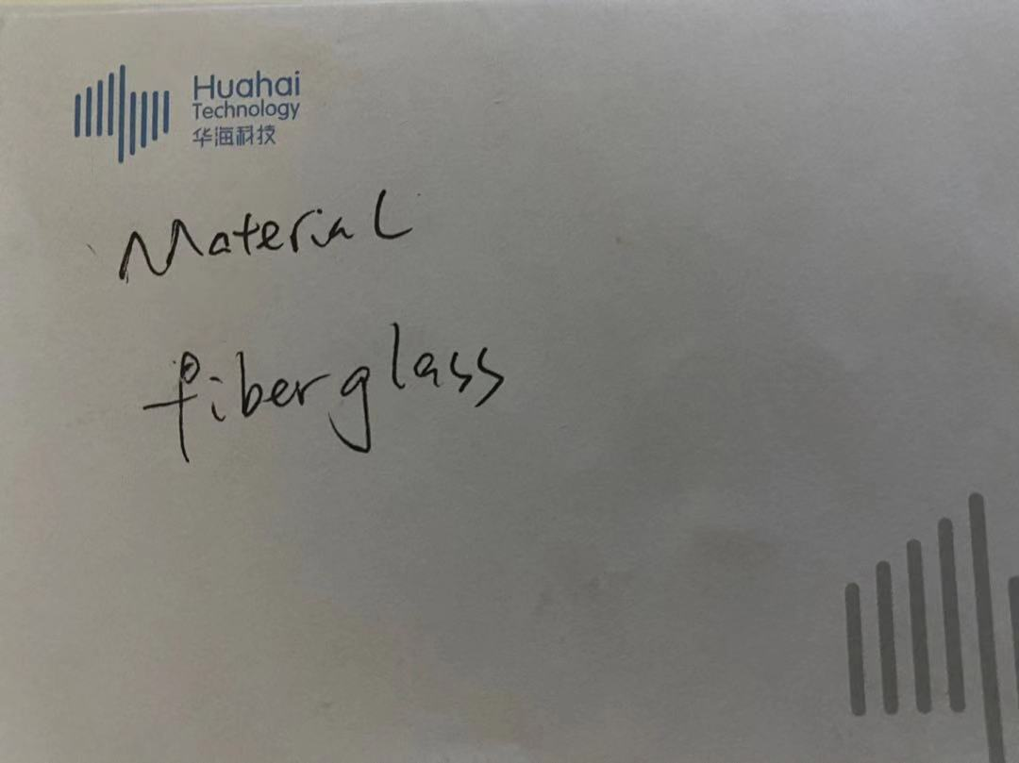

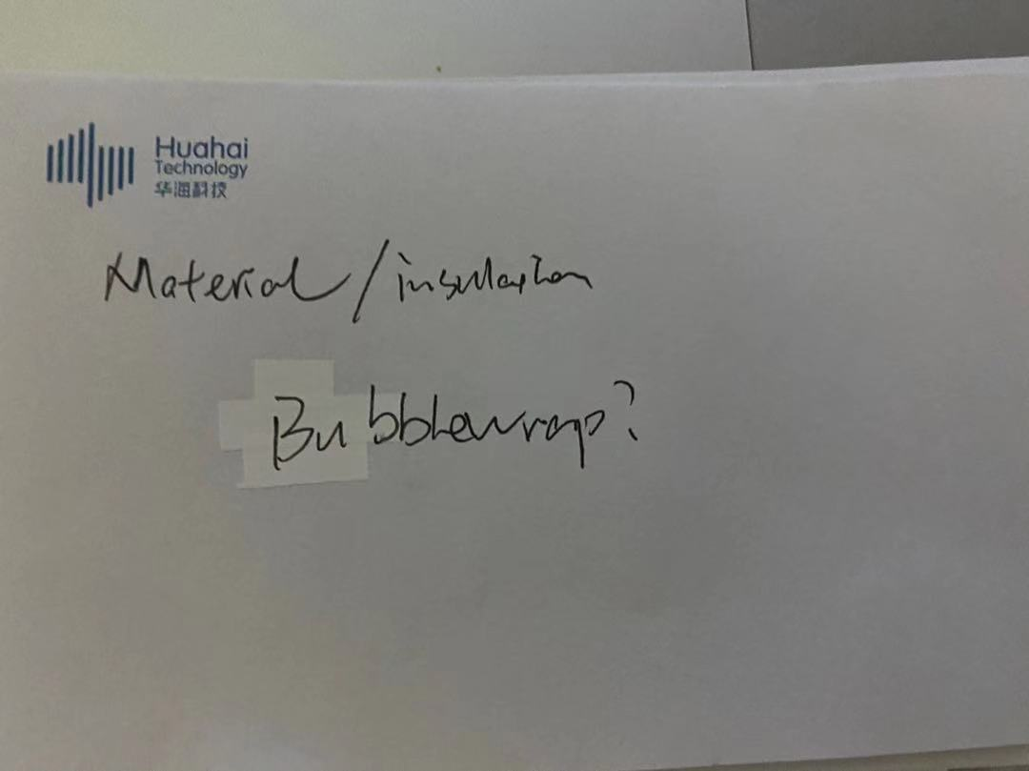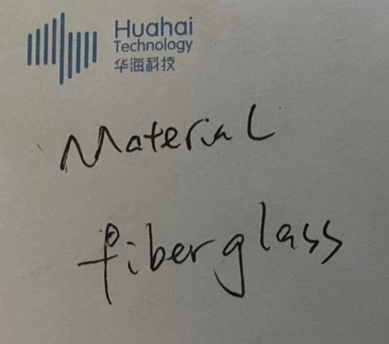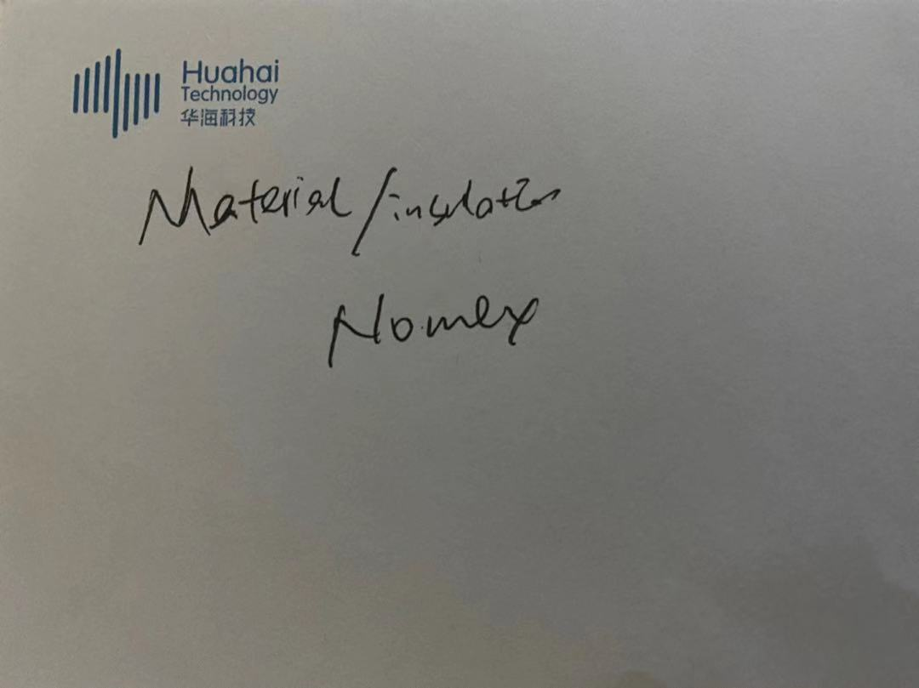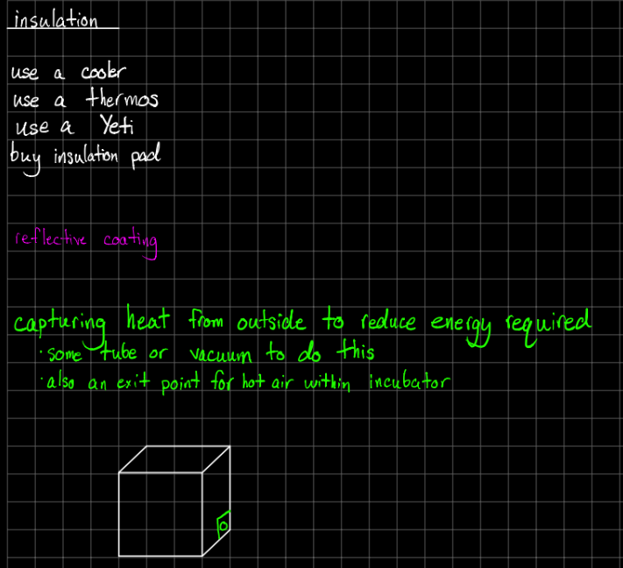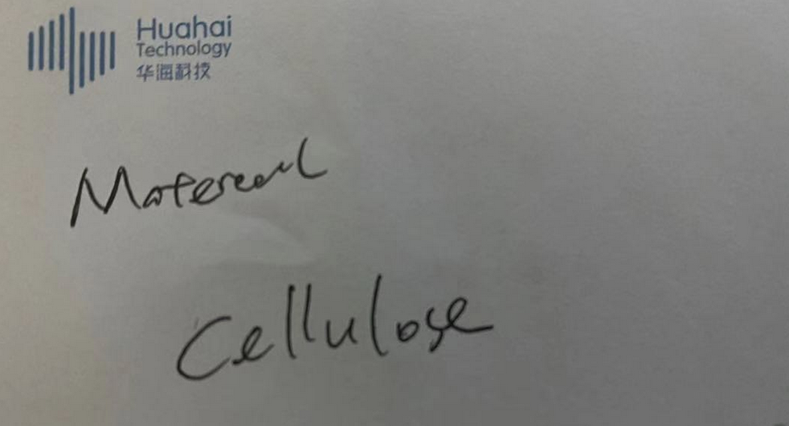

***Figure 6: Materials/Insulation Brainstorming***

An assortment of sticky notes and notes depicting ideas that our team had for materials/insulation

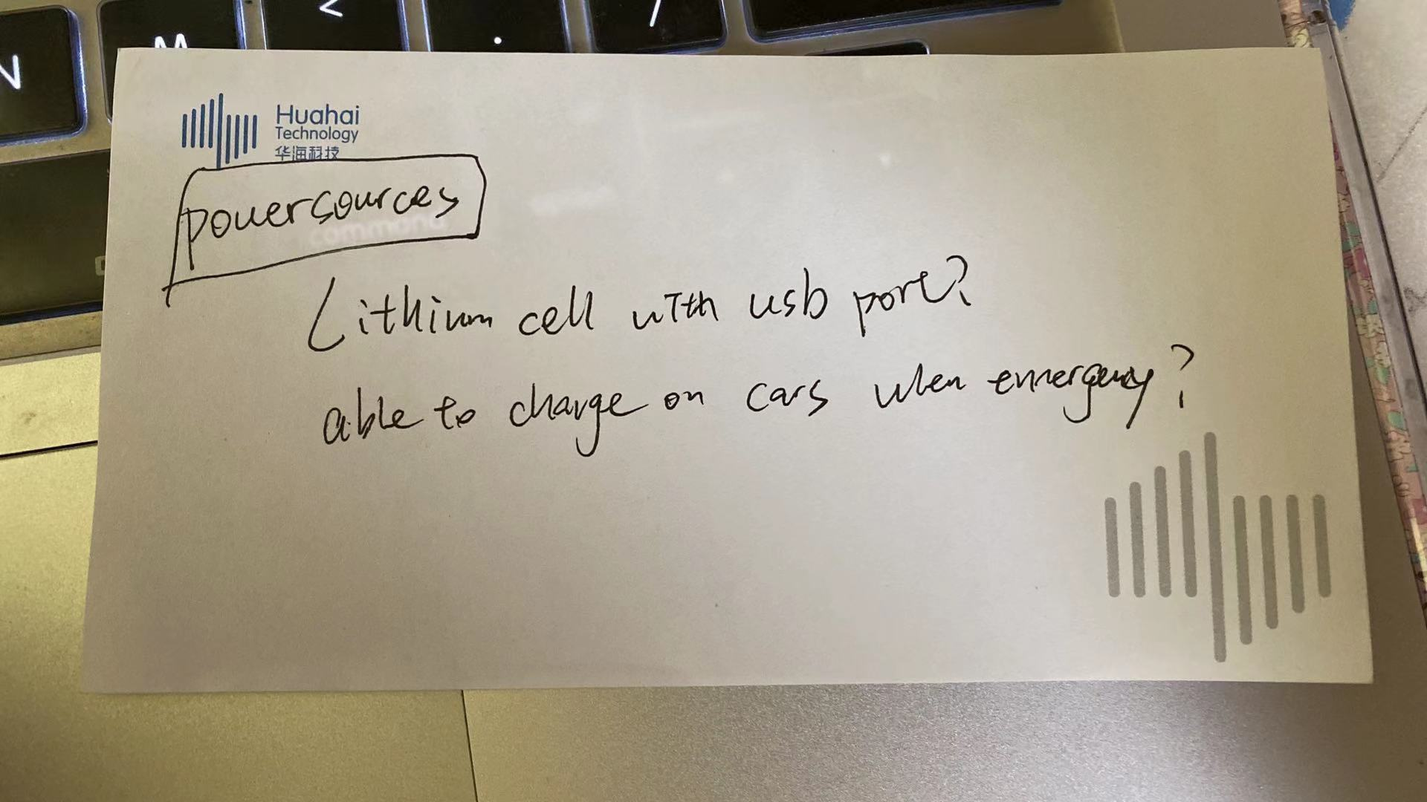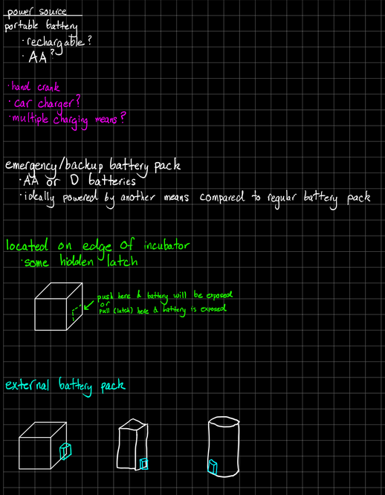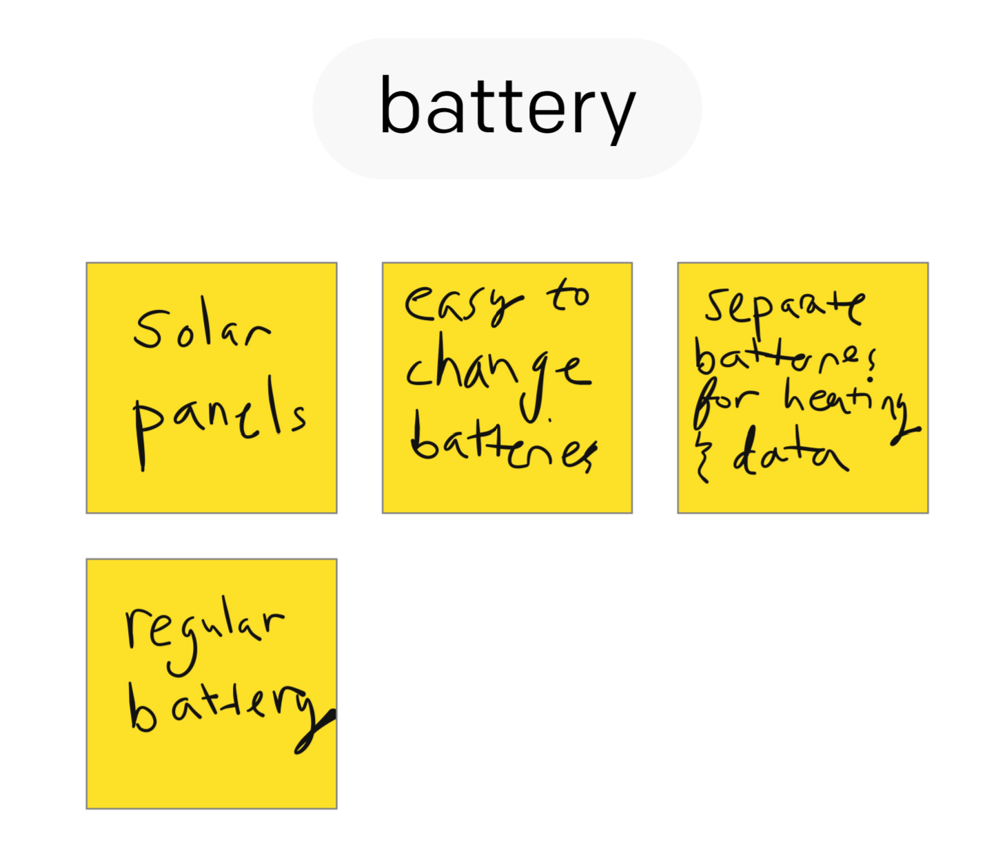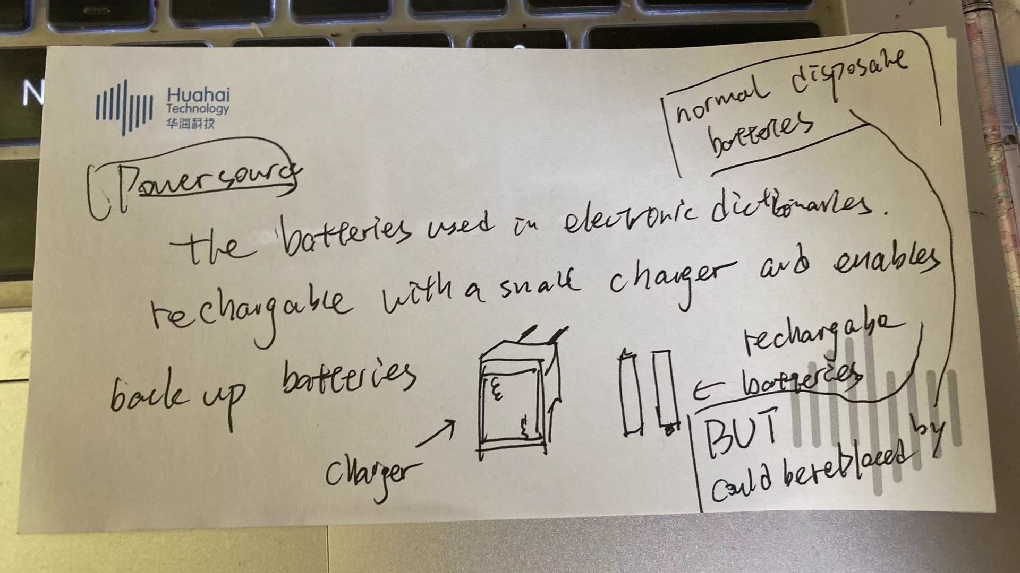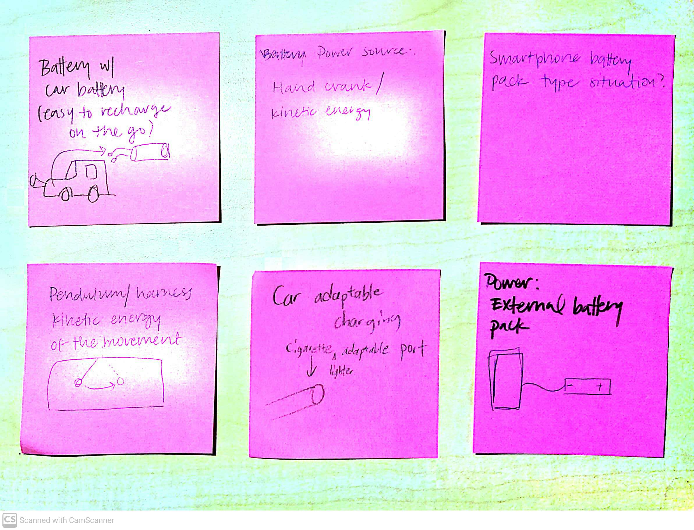

***Figure 7: Power Source Brainstorming***

An assortment of sticky notes and notes depicting ideas that our team had for types of power sources and their potential locations

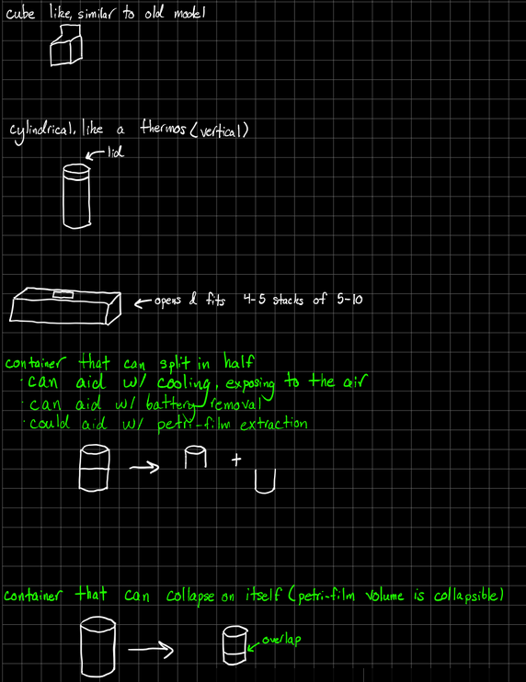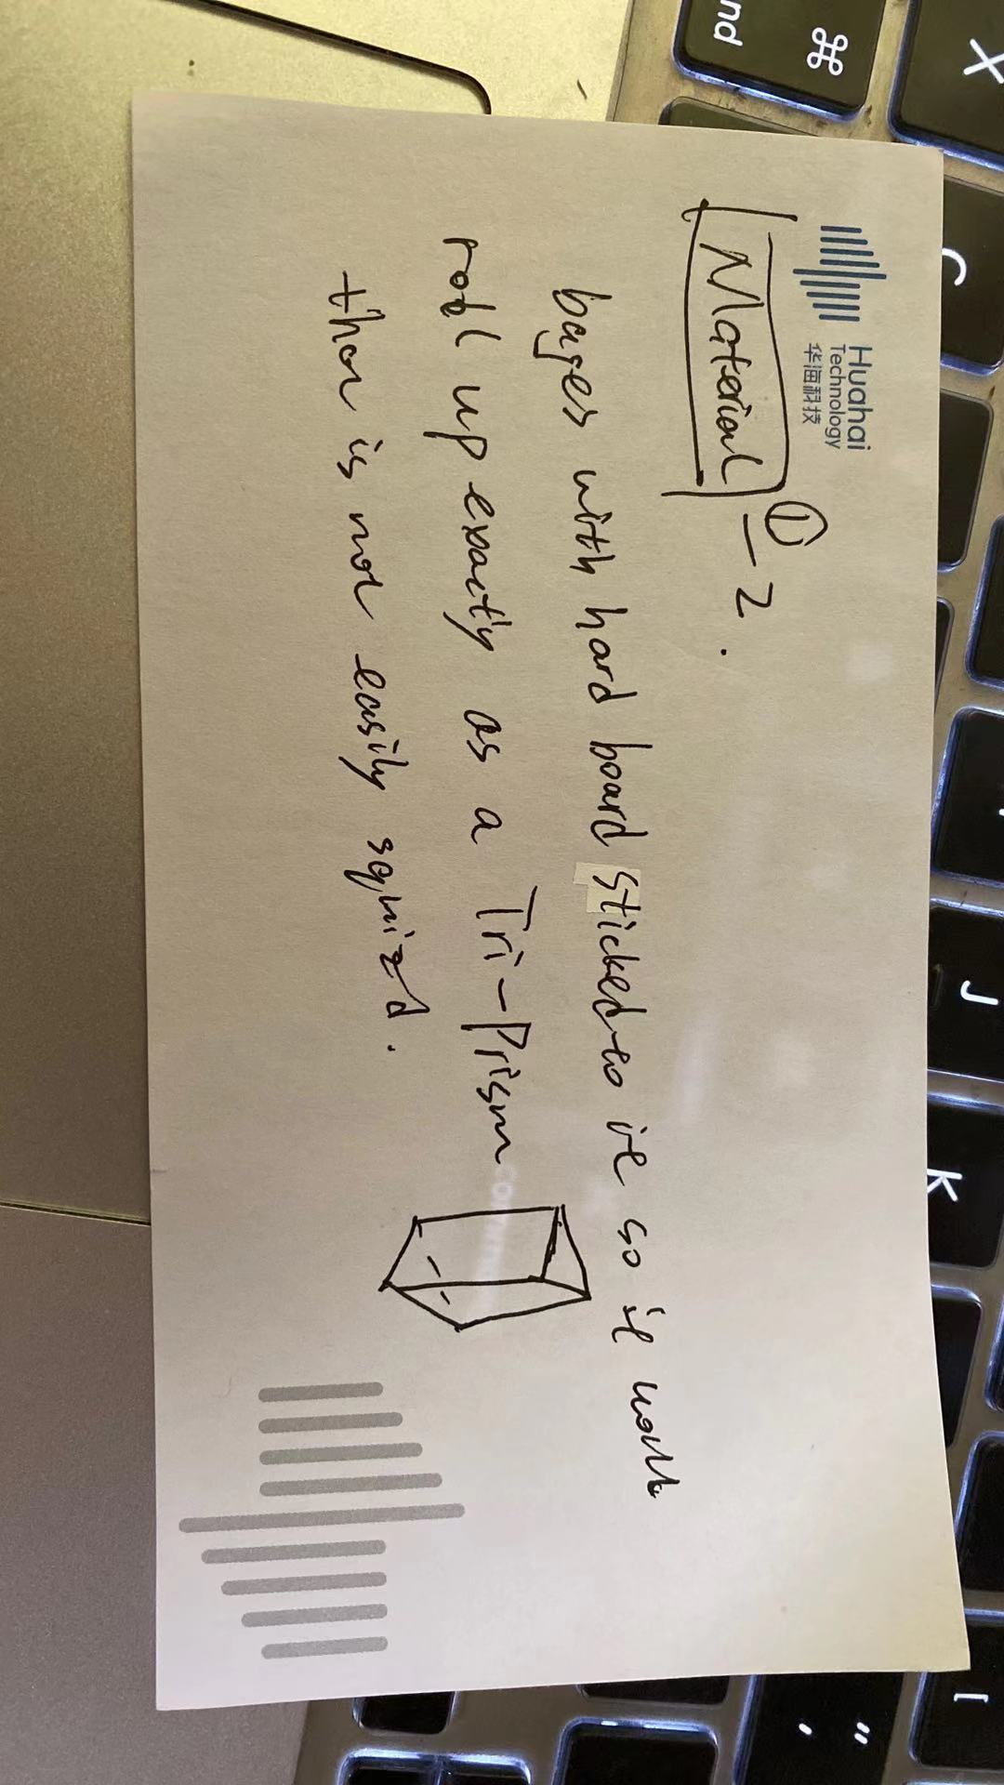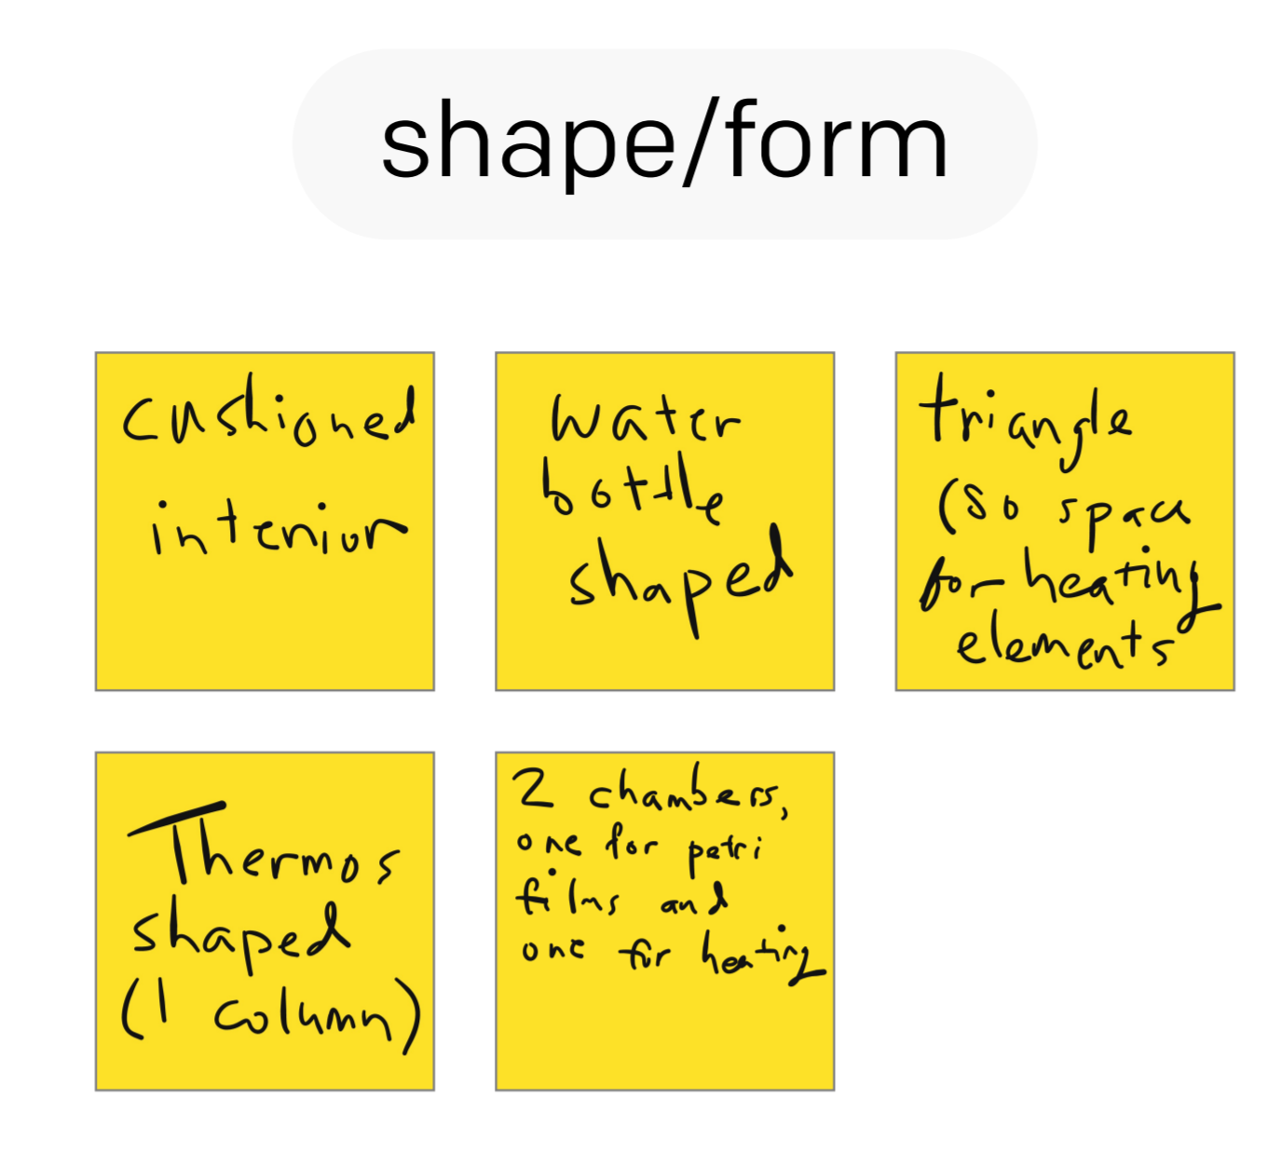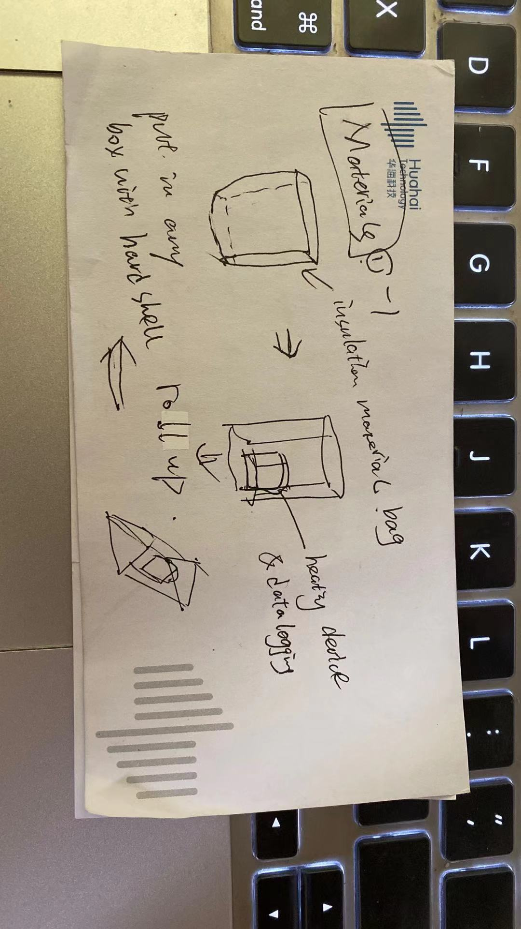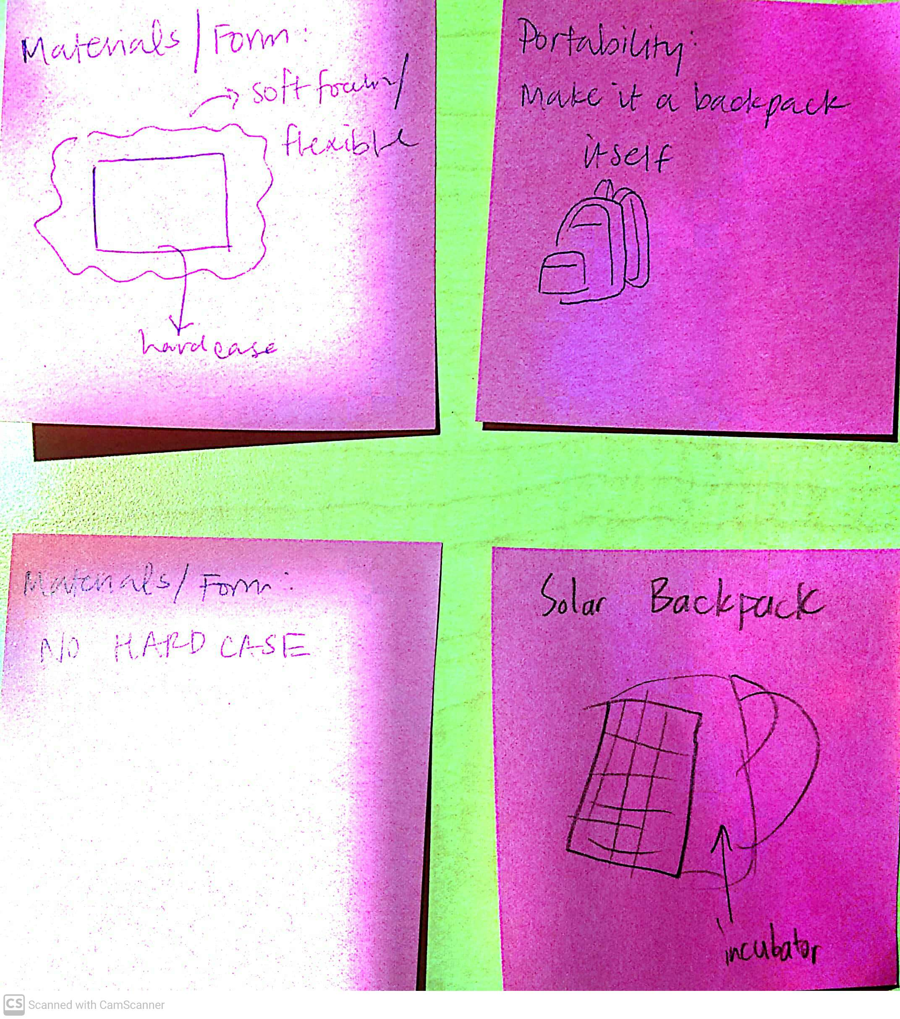

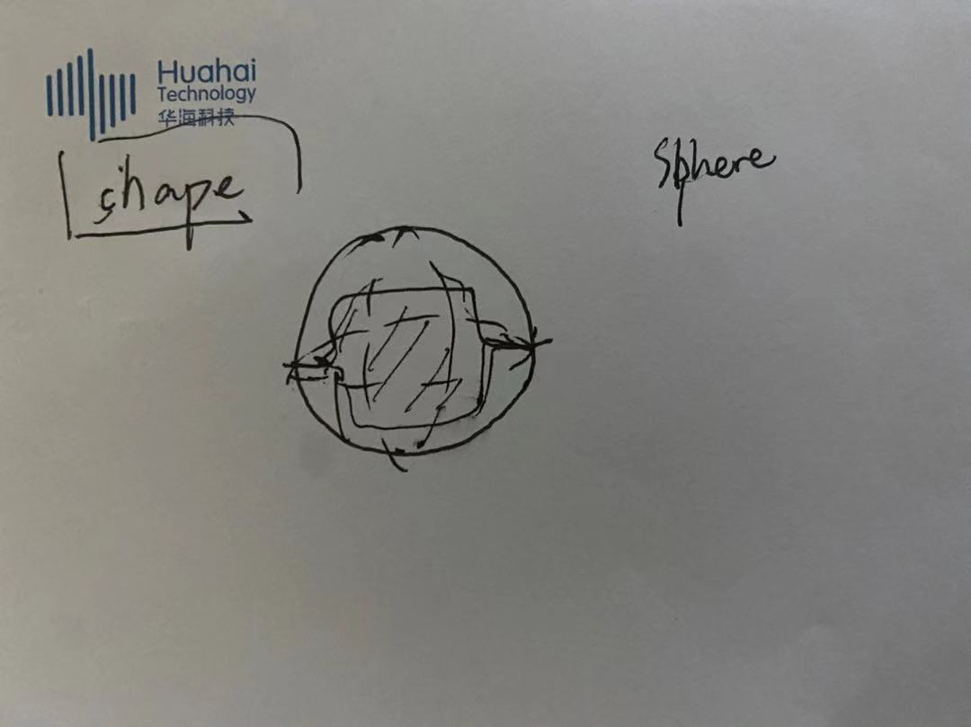

***Figure 8: Shape, Materials Brainstorming***

An assortment of sticky notes and notes depicting ideas that our team had for various materials and shapes that we could use in our incubator

**Conclusion**

While our team mainly utilized the slip method of brainstorming, we quickly realized that our team worked better with shorter time intervals. This allowed us to generate ideas and not waste time. Furthermore, we scheduled multiple brainstorming sessions at different times of the week, which allowed us to do research and think in between meetings. Despite not using the card method, we hitchhiked off of each other's ideas while discussing the ideas we had come up with individually, Some of our best ideas came to fruition during the time that we were hitchhiking off of each other. There were often times that we began to circle around the same ideas even with tools like SCAMPER, and we used this as a sign to switch to a different block and return to the original, or just regroup a different day with a fresh mind. One memorable moment was when we realized that we might be able to make cooling a secondary component of our design by utilizing manual cooling, thus making our final design easier.

1. Main Writers: Michael Tang and Sindhuja Darisipudi